**PYCITYSCHOOLS ANALYSIS:**

Provided PyCitySchools “schools_complete” and “students_complete” .csv files contained data on the student body as well as various schools, which were combined into a single dataset for analysis. A total summary of the combined school data is as follows:  
A more granular cross-sectional analysis of the 15 schools was performed, noting items such as school type, students per school, school budget, and math & reading metrics:

* In the analysis it was discovered that the school’s spending per student had no bearing on that overall percentage of students that were considered passing, as evidenced by the top 5 highest performing schools all having lower spending per student than the lowest 5 performing schools (~90%+ passing vs ~53% passing).
* 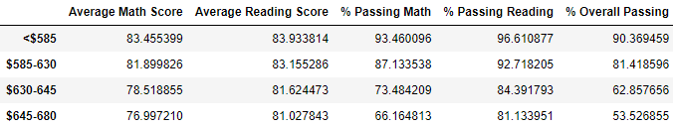This phenomenon was further explored by analyzing spending per student relative to math & reading scores, which revealed that *lower* spending per student resulting in higher scores and a higher overall passing rate.

Further analysis was performed by looking at scores and passing rates relative to school size and school type:

* 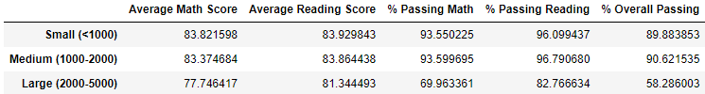In the analysis it was discovered that schools with 2000 or less students (small & medium) tended to outperform larger schools (2000 – 5000 students), as evidenced by both scores and pass rates.
* Additionally, Charter schools vastly outperform District schools with respect to the percentage of passing students, though only some minor differenced in average reading scores is noted.

